STANDARD ACL CONFIGURATION

HOW TO CONFIGURATION STANDARD ACCESS CONTROL LIST

Inacio Andre

2024

// TOPOLOGY //

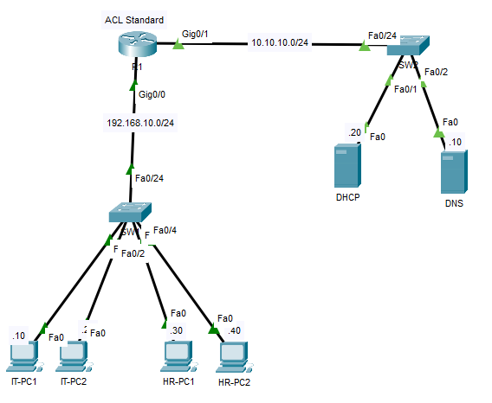

// Basic Configuration //

\*\*R1

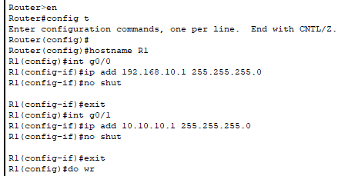

// Test Communication //

IT-PC1 TO DHCP SERVER

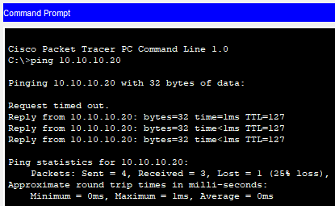

HR-PC1 TO DHCP SERVER

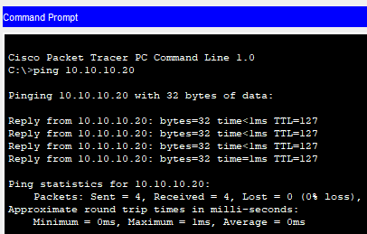

// ACL Standard Configuration //

\*\*R1

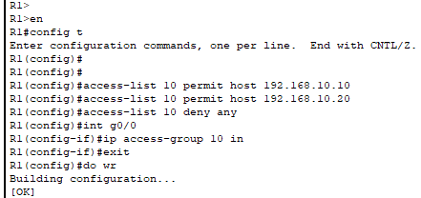

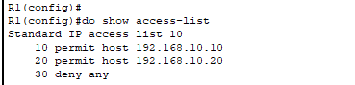

// Test Communication //

IT-PC1 TO DHCP SERVER

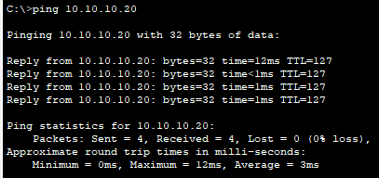

HR-PC1 TO DHCP SERVER

